Grade Journey for eLearn Ultra (Gradebook)
- For the teaching course site
Step 4: Grade Approval and Transfer


This guide explores on how to trigger the grade approval and transfer from eLearn to EMX. Before performing the grade transfer, ensure all grades are posted and all SYS columns are configured.

Click Content and navigate to the Details and Actions panel on the right.
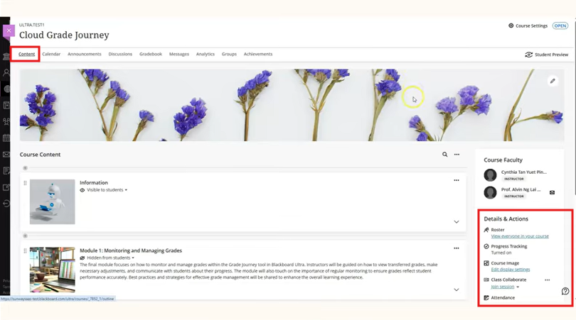

Under Book and Tools, click the View Course and Institution Tools link.
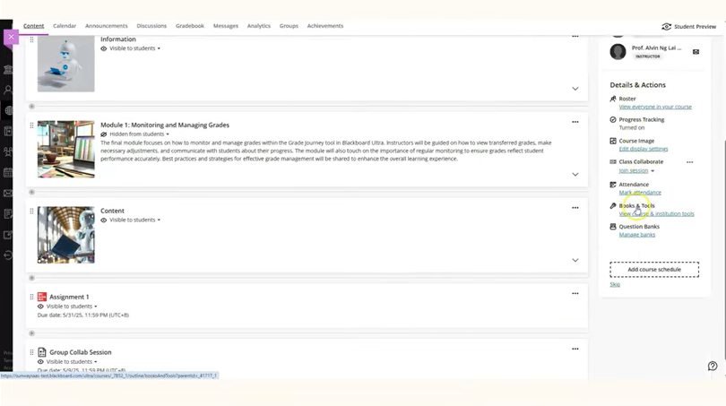
Click on Grade Approval and Transfer.
If the approval status shows Unapproved, it means the grade hasn't been approved yet.
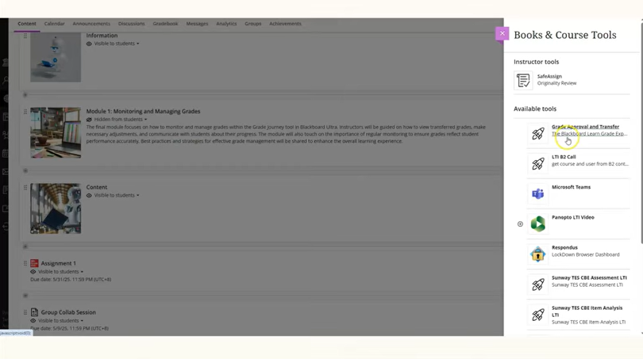

To approve the grade, tick the checkbox next to the Course ID and click Approve Grades.
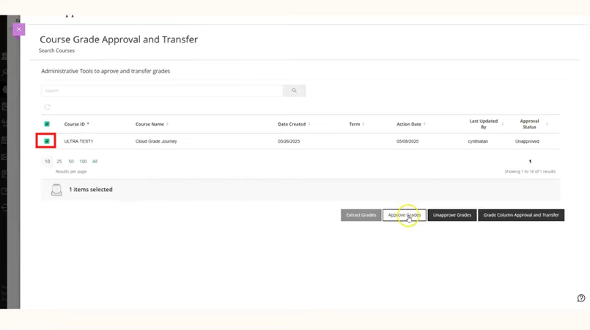
Click OK to confirm.
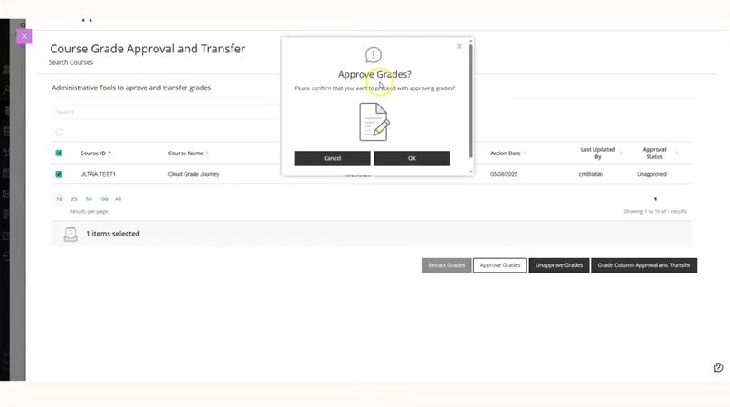

A green status bar with the message Grades were successfully approved will appear. The approval status will now change to Approved. The system will extract the approved grade and transfer it to EMX when the scheduled job runs.
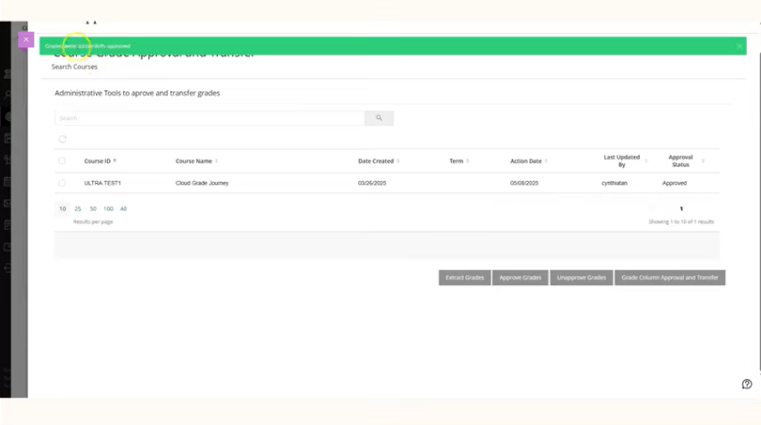
Once the grade is extracted, the approval status will change to Extracted, indicating that the grades have been transferred to EMX for processing.
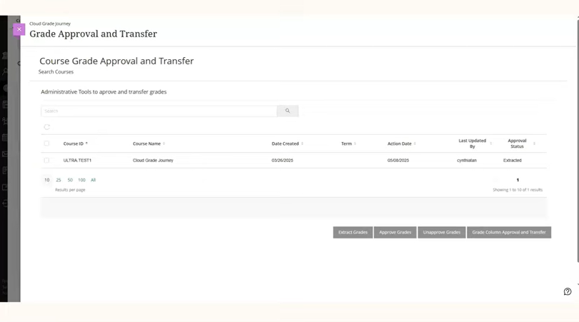

End of Guide

